**Home Assignment:**

**Create, Update, and Delete Change Requests with Chaining Process in Postman**

**Learning Objective:**  
The objective of this session is to learn how to create, update, and delete change requests in ServiceNow using a chained process in Postman, and to save and reuse the sys_id from one request to the next.

**Expected Completion Time:**

* Best Case: 40 minutes
* Average Case: 50 minutes

**Session Details:**

**ServiceNow API Credentials:**

1. **Obtain Your ServiceNow Instance Credentials and set this in a collection level:**
   * Instance URL , Username & Password

**Creating, Updating, and Deleting Chnge Requests:**

**Part 1: Create a Change Request**

**Step 1: Create a new collection**

* Create a collection for chaining of request.
* Set the Authorization as Collection Level.
* 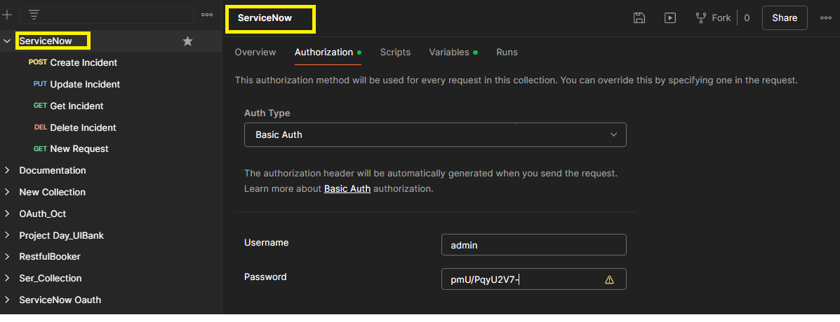

**Step 2: Create a New Request**

* Click on "New" and select "HTTP Request".
* Name your request appropriately, e.g., "Create Change Request".

**Step 3: Set Up the Request URL**

* Set the request type to **POST**.
* Enter the ServiceNow API endpoint for creating a change request:

**POST** https://<your_instance>.service-now.com/api/now/table/change_request

* Replace <your_instance> with your ServiceNow instance name.

**Step 4: Authentication**

* Go to the "Authorization" tab.
* Select "Inherit auth from Parent".

**Step 5: Body**

* Switch to the "**Body**" tab.
* Select raw and choose JSON from the drop-down menu.
* Enter the JSON payload for creating a change request. Example:

{

    "short_description":"Chaininig of request",

"short_description":"Create Changerequest"

    }

**Step 6: Save the Response as a Variable**

* Go to the "Tests" tab and add the following script to save the response as a variable:

*var* resp = pm.response.json();

*var* sysid = resp.result.sys_id;

pm.globals.set("cr_SysId", sysid);

pm.test("Status code is 201", *function* () {

pm.response.to.have.status(201);

});

**Step 7: Send the Request**

* Click "Send".
* Observe the response in the lower pane Body tab and ensure it contains the details of the newly created change request, including the sys_id.
* Check whether the Response code is 201.
* And Ensure the Test results.

### Part 2: Read the Change Request

**Step 1: Create a New Request**

* Click on "New" and select "HTTP Request".
* Name your request appropriately, e.g., "Read Change Request".

**Step 2: Set Up the Request URL**

* Set the request type to **GET**.
* Enter the ServiceNow API endpoint for reading a change request:

GET https://<your_instance>.service-now.com/api/now/table/change_request/{{changeRequestSysId}}

* Replace <your_instance> with your ServiceNow instance name. The {{changeRequestSysId}} is the global variable set in the previous step.

**Step 3: Authentication**

* Go to the "Authorization" tab.
* Select "Inherit auth from Parent".

**Step 5: Send the Request**

* Click "Send".
* Observe the response in the lower pane Body tab to ensure it contains the details of the change request.
* Ensure the status code is **200 OK**.

**Part 3: Update the Change Request**

**Step 1: Create a New Request**

* Click on "New" and select "HTTP Request".
* Name your request appropriately, e.g., "Update Change Request".

**Step 2: Set Up the Request URL**

* Set the request type to PUT.
* Enter the ServiceNow API endpoint for updating a change request:

**PUT** https://<your_instance>.service-now.com/api/now/table/change_request/{{changeRequestSysId}}

* Replace <your_instance> with your ServiceNow instance name. The {{changeRequestSysId}} is the global variable set in the **POST** Request.

**Step 3: Authentication**

* Go to the "Authorization" tab.
* Select "Inherit auth from Parent".

**Step 4: Body**

* Switch to the "Body" tab.
* Select raw and choose JSON from the drop-down menu.
* Enter the JSON payload for updating the change request. Example:

{

    "short_description":"Chaining for change request ",

"short_description":"Update Request"

    }

**Step 5: Validate the Response body**

pm.test("Body matches string", *function* () {

 pm.expect(pm.response.text()).to.include("My laptop is Replaced");

});

* Add the snippet in Scripts Tab.

**Step 5: Send the Request**

* Click "Send".
* Observe the response in the lower pane Body Tab and ensure it contains the updated details of the change request.
* Ensure the status code is **200** andthe Test results.

**Part 4: Delete the Change Request**

**Step 1: Create a New Request**

* Click on "New" and select "HTTP Request".
* Name your request appropriately, e.g., "Delete Change Request".

**Step 2: Set Up the Request URL**

* Set the request type to **DELETE**.
* Enter the ServiceNow API endpoint for deleting a change request:

**DELETE** https://<your_instance>.service-now.com/api/now/table/change_request/{{changeRequestSysId}}

* Replace <your_instance> with your ServiceNow instance name. The {{changeRequestSysId}} is the global variable set in the **POST** Request.

**Step 3: Authentication**

* Go to the "Authorization" tab.
* Select "Inherit auth from Parent".

**Step 4: Send the Request**

* Click "Send".
* Observe the response in the lower pane to ensure the change request has been successfully deleted.
* Check the Status code is **204** No content.

**Expected Outcome:**

Upon completion, you should be able to:

* Create a change request in ServiceNow via API and save the sys_id.
* Update the change request using the saved sys_id.
* Delete the change request using the saved sys_id.
* Understand how to chain requests in Postman by using variables.